STEPS TOWARD DEVELOPING AN INTELLIGENT ROBOTICS COURSE

Oskars J. Rieksts and Jeffrey W. Minton
Kutztown University
rieksts@kutztown.edu and jmint580@live.kutztown.edu

ABSTRACT
Industry leaders and educators have recognized the rising importance of interactive robotics and foresee courses in robotics software as mainstays in the computer science curriculum. We report here on the ongoing process of developing a course in intelligent robotics and on the progress made to date.

KEY WORDS
Robotics, iRobot Create, Image Processing, MATLAB

1. Introduction

Today many robotics applications have a significant software component. Not surprisingly it has been recognized by both industry leaders and educators that a course focusing on the software side of robotics belongs in the undergraduate computer science curriculum. David Touretzky of Carnegie Mellon, in his recent CACM article, "Preparing Computer Science Students for the Robotics Revolution," states that "Robotics will inspire dramatic changes in the CS curriculum." [1] Bill Gates also, in his Scientific American article, "A Robot in Every Home," [2] sees robotics as the next hot field in computer science.

The areas of greatest commonality between robotics and software engineering occur in mobile, autonomous robotics which also require the most in terms of decision-making and intelligence. In addition, the development trajectory of robotics indicates that in the near future robots will be found in the living and working spaces of people, as predicted by Gates. This puts a high priority on the development of means of communication between robots and humans.

Ideally, a robotics course in the computer science curriculum would incorporate mobility, autonomy in decision-making, and communication. We report here on the design and implementation of a course in intelligent robotics at Kutztown University during the Summer and Fall of 2010.

2. Course Design Objectives

For maximum impact a robotics course in the computer science curriculum should be readily accessible to the average computer science major who has no special preparation in electronics. Thus, the majority of the work expected of students in such a course would focus on software and not on hardware. And, both from the standpoint of student interest and for sound pedagogical reasons, the robot should be capable of performing tasks reasonably high on the intelligence scale.

The basic framework projected for the course was a robot operating in an environment shared with humans and in communication with humans. While the robot would be mobile and capable of autonomous action it would also be capable of taking directives from a person. This framework imposes a number of constraints on the design of the robot.

First, it must be situated, embedded in the sense of Randall Beer [3], and embodied. Right from the start, the robots would operate within an environment with an emphasis on working with a data stream drawn from the environment, while minimizing the use of pre-existing knowledge of its surroundings. This, of course, draws upon the pioneering work of Rodney Brooks [4] and the behavior-based design described by Maja Mataric [5].

Second, there must be a set of concepts and facts about the environment shared by man and machine as well as a communication framework common to both. Since the most natural human sensory system is vision, the ideal robotics sensory system would include and strongly feature acquisition and processing of "visual" data.

These objectives lead to the following course topics and activities: (1) mastery of the software systems which control the basic operation of robot, (2) understanding and implementing a robot control architecture, (3) understanding the basic concepts of image processing, (4) mastery of specialized image processing software, (5) understanding and implementation of the basics of communication theory, and (6) understanding some of the key philosophical issues of cognitive robotics such as the theory of referents as explored by Kronfeld [6], the symbol grounding problem posed by Harnad [7], and the interactivism of Bickhard [8].

The challenge is to cover these topics in a non-trivial way while keeping the course accessible to a sufficiently wide audience.

3. The Hardware and Software Platform

In order to meet the above course objectives, an appropriate hardware and software platform must be in place. Desired properties of such a platform are a plug-and-play type of boot up of the robot, a good sensor and actuator suite, hardened (robust) hardware components, an API to enable higher level programming of the robot, and an over-arching software system to tie it all together.

This combination of desiderata, it turns out, is not easy to achieve at a cost accessible to the small to medium sized university budget. For the past five years the first author has offered aspects of robot programming in a special topics course, as a major topic in artificial intelligence courses, and in conjunction with projects in senior seminar classes. Various hardware and software platforms have been used: hacked Roombas from iRobot, Lego Mindstorms kits (some running the original software and others running Lejos) Vex robotics kits, the Myro "personal robot," and various robotic configurations assembled from components.

This early experience constituted a valuable learning curve in two respects. First, it brought into sharper focus the necessary features of a workable system. Second, it showed that there was significant interest in robotics among computer science students.

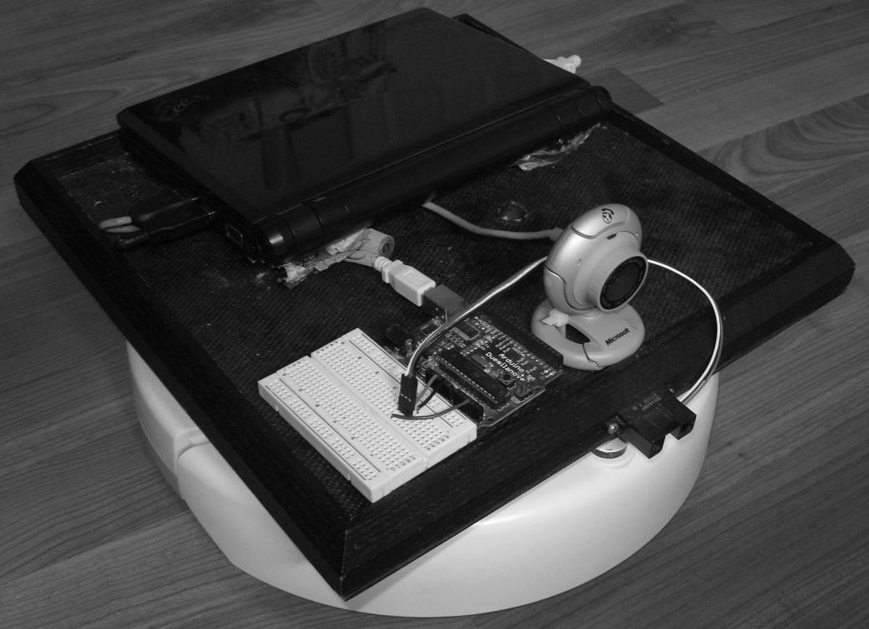
Figure 1: The Create robot with camera, Arduino and netbook

Late in the spring of 2010 the first author received a SSHE Faculty Professional Development grant to develop an intelligent robotics course. The second author, a graduate student, worked with him on this project during the summer and fall of 2010. He had previously built a robot to enter the Trinity Fire Fighting Robot competition. That design consisted of a repurposed Vex chassis augmented with camera, sonar and IR sensors and controlled by an onboard netbook in concert with an Arduino microcontroller. It marked the first time he had experimented with the use of a personal computer to control the operations of a robot. The computer proved to be necessary to accomplish the processing of images as the microcontrollers used in the past had insufficient processing power for the task.

The design goal of the robotic platform for the course was a combination of hardware and software which would afford the opportunity for significant intelligence in control and decision-making. In addition, we wanted the configuration to have an open-ended quality which would allow the course content to grow, with time, in complexity and challenge. In particular, a major goal for us was to aim for communication and collaboration between robot and human. This was inspired by the clear need for robot-human communication for any viable robotic wheelchair system, as well as for the burgeoning field of assistive robotics. This pushed us toward continuing with the use of a camera as a major source of information about the environment. Our collective experience gave us a predilection to using the design of the fire fighting robot as a starting point while making appropriate adjustments.

In addition to taking advantage of previous experience (and striving to overcome the shortfalls of previous systems), the authors drew upon the significant experience of John Spletzer of Lehigh University and consulted also with John Grenzer, Vice President for Technology of The Good Shepherd Rehabilitation Hospital in Allentown, PA. Spletzer teaches a robotics course in the Computer Science Department at Lehigh, was a team leader for the Little Ben entry in the DARPA Urban Challenge [9], and is lead developer of a self-stowing robotic wheelchair [10]

Since the computer science department already had several iRobot Creates, to keep costs down, it made sense to use them as the base robot and to add an onboard computer for the control software. This was similar to the setup Spletzer used for his robotics course and in our conversations with him we were assured that it was a viable platform. The onboard computer was to be an Asus Eee PC 1000HA. The netbook contains an embedded camera but we wanted a camera with a wider view. So we chose the Microsoft LifeCam for its 71 degree viewing angle. As in the fire fighting robot, an Arduino microcontroller gave us the flexibility of adding sensors. At this point, though, the only sensor we have added is the Sharp GP2Y0A02YK0F IR rangefinder. These sensors work by sending out pulses of infrared light and measuring the time lapsed until the light from the pulses returns to the sensor, after reflecting off a surface. This allows the robot to gauge the distance to an object in front of it, something that is much harder to do using the camera image alone.

In terms of software, the initial plan was to run Ubuntu Linux with Python as the main programming language and to use OpenCV [11]for image processing. It soon became clear that OpenCV did not provide an entry point at a sufficiently low level for the average computer science major. John Spletzer uses MATLAB for much of his robotic work. He recommended that software package to us and offered us the use of a Create API written in MATLAB. There is also an excellent reference on the use of MATLAB for image processing [12].

Using FPDC grant funds we purchased a classroom license of 10 copies of MATLAB. Five copies were loaded on the netbooks to control the robots, four were put in a computer lab for students use and one was allocated to the course instructor for class preparation. The choice of MATLAB also dictated that we use Windows as our operating system. Right before the start of the semester we made the switch. At this time, too, the University Carpenter Shop built a platform to house the netbook, the camera and the microcontroller. We had sufficient funds in the FPDC grant for 4 complete systems. Using the netbook from the fire fighting robot we had a 5th system for the graduate assistant. Figure 1 shows the completed configuration.

The merging of multiple systems was first approached in the Fire Fighting Robot Competition. In that system, a laptop could not control the VEX robot on its own so it was necessary to create software that allowed the computer to exchange information with the Arduino. The microcontroller would then control the motors and actuators of the Vex and get data from sensors that could be reported back to the computer. For the iRobot Create the Arduino was no longer necessary for controlling the sensors and actuators of the Create, since the computer sent commands directly to the Create using the MATLAB API. Instead the Arduino is included in the configuration to allow the addition of sensors that the Create does not have, as required. The interface with the microcontroller is done using an Arduino toolbox built for MATLAB.

4. The Robotics Course, the Next Iteration

The development of robotics at Kutztown University has proceeded in a series of incremental steps. As mentioned above, robotics has been offered to students in various ways including student projects in the senior seminar class, individual student research projects (some funded by the University Undergraduate Research Committee), a component of AI courses, and as a special topics course. This work has proceeded on a wide variety of platforms, as described above.

The constant in this has been slow, steady progress toward better hardware platforms as well as a more solid software basis and programming experience. Another constant has been Robert Browning's dictum, "A man's reach should exceed his grasp, or what's a heaven for." At each juncture our reach has exceeded our grasp, but that has also served to impel us further along our trajectory. As computer scientists we are no strangers to the concepts of rapid prototyping and iterative development. And this describes our efforts in developing an intelligent robotics course. What we described in this paper is the most recent iterative step in this process.

4.1. Structure of the Class

The course, entitled Intelligent Robotics, was offered in the Fall of 2010 as a special topics course at the 400 level, with 14 students enrolled. Although it was open to both graduate and undergraduate students, all but one of the students were undergraduates. We had available to us four iRobot Create robots equipped with webcams and netbooks, as described above. The graduate assistant had a fifth system built partially from equipment from his fire fighting robot. The class was divided into four teams with a robot assigned to each team. The teams were organized, partially by the instructor and partially by the team members. Each team had a team leader appointed by the instructor and designated roles decided by members themselves. Since the number of roles exceeded the team size, most students had to assume at least two roles.

The designated roles for each team were as follows:
designer - design the solution to the assigned tasks
coder - chief responsibility for coding the solution
document guru - go-to person on questions relating to the specialized hardware and software in use
historian - keep track of team's progress and write reports on work accomplished
test designer - design tests to gain better understanding of robotic system functionality and limitations
test administrator - oversee the testing process
hardware specialist - the go-to person for hardware related problems

Some of these roles bear further explanation. Since there was only one copy of MATLAB for each team the brunt of the coding could only be done on the OBC (i.e., the netbook). Therefore, one person was designated as the chief coder. The various components of the robotic system came with user's manuals and other forms of documentation, some of it voluminous. MATLAB, for example, comes with 17 PDF files of documentation comprising 63.5 MB. Hence the need for a document guru exists. Even though every effort was made to use hardened components not liable to failure, the person with the most hardware experience would be called upon if hardware problems arose. Finally, since ultimately robotics is situated within the real world and is hardware based, one can never be sure that a particular aspect of functionality will operate as envisioned. Therefore, it is imperative that tests be designed to gain understanding of both the capabilities and the limitations of the robot. Ideally, the design and administration functions of testing should not be carried out by the same person in order to leverage maximum objectivity in the testing process.

4.2. Our Experience

Initially our objective was to have the class build a complete robotic control system capable of mapping an environment, recognize objects in its world, communicate with humans concerning its environs, report information to persons, and receive and carry out directives.

As we began to wrestle with the complex new software and the intricacies of image processing, it became clear that for this, our initial offering of intelligent robotics, we would have to scale back our expectations. In addition, we encountered a number of unanticipated impediments to progress.

One of these bottlenecks was the limitation on access to MATLAB. In theory, having copies of the software available in the computer science computer lab, in addition to the copies residing on the netbook was a reasonable compromise. In practice, however, most teams relied heavily on the team's coder while other team members worked only minimally with MATLAB. This impacted the team's design process which, to be effective, required that all team members be reasonably competent in MATLAB.

Several other factors impeded our progress during the semester. The first was the PACT demonstration, discussed in Section 4.3, which turned out to be a mixed blessing. The second was difficulty in finding a venue for development. A few weeks into the semester it became evident that the hallways of the computer science department could not serve this purpose, due to insufficient lighting and the dark color scheme. The invitation to participate in the PACT Conference provided a venue for 2-3 weeks only. Numerous inquiries to room scheduling offices revealed that space on campus was tightly booked. Finally, we learned that the old gymnasium was under-utilized because it had not been updated to allow handicapped access. After an inordinate number of additional emails, phone calls and visits to the university's conference services office we were able to obtain use of this venue, though not at the most optimal times.

The biggest factor, however, constraining our ability to fully implement our planned system was the image processing learning curve. Although MATLAB gave us a much higher entry level than OpenCV, there was still much work to be done to apply MATLAB's functionality to our specific needs. Two examples of the kind of processing involved are discussed in Section 5.

4.3. The PACT Demonstrations

Early in the semester we learned that the university was to host the annual Pennsylvania Association of Council of Trustees (PACT) Conference and that the Dean of Liberal Arts and Sciences had chosen to showcase the computer science department. We were invited to prepare a presentation for that conference. This presented both an opportunity and a challenge. We felt that a good showing there would serve to open doors for robotics courses within the State System of Higher Education (SSHE) by predisposing trustees at various sister institutions to supporting such efforts. Yet it was an immense challenge since the date of the meeting was too early in the semester for the subject matter of the course to have reached the proper level of maturity.

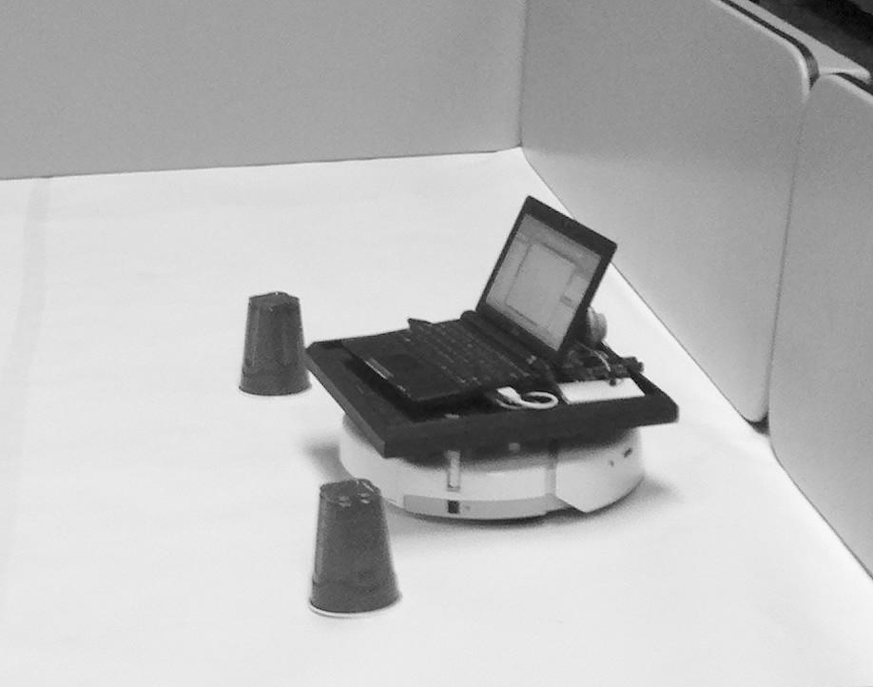
Figure 2: The robot after navigating between two red cups

To comply with the new deadline we focused our efforts on simple tasks for the robots to perform within a constrained environment. We had been assigned a meeting room in the Student Union building for our presentation. Using tables already in the room, we turned them on the side to create a corral-type environment. A number of tasks were proposed to the class with each team having leeway in its choice of task and implementation. The one constant was that the robots had to use the webcams for navigation.

The teams used various cues for orientation within the corral. One team used color swatches; another created different patterns of black stripes on rolls of white paper towels; others used red plastic cups and black dowel rods for this purpose. The graduate assistant had his robot locate and then navigate between two red cups, as shown in Figure 2. Surprisingly, the hit of the demonstration was the "bull fighting robot" which located and then charged a red towel held by one of the students, then turned to charge again. There was a good-sized and lively crowd in attendance. And, judging from their comments and the enthusiastic applause, one can hope that the trustees have gained a greater interest in seeing robotics in the curriculum at SSHE schools.

4.4. The Final Projects

As already mentioned, during the course of the semester we had to scale back our goals for this iteration of the course. For example, whereas we had projected a blackboard based control system, we implemented instead hand coded logic on a task by task basis. There was a key aspect of our original goal set, though, that we did not want to compromise. Kronfeld shows the importance for communication of establishing a shared set of referents. Although a human and a robot will have very different internal representations of an object in their shared environment it is critical that there be a way to establish, within a conversational context, that both entities are, in fact, making reference to the exact same object in that environment. Applying this in the human-robot context is an active area of research [13].

Therefore, central among the final set of tasks given to each team was to establish a shared set of referents, albeit in a primitive way. Five objects were to be placed in a line. The robot would pass along the line of objects, create an internal representation of each object, and inquire of and receive from its handler the name of each. After that, the objects were reordered. This time the robot would go down the line, recognize each object, and output its name.

Among the other tasks performed by some, though not all, teams were navigating through an obstacle course on the basis of a supplied occupancy grid, recognizing objects by shape, and using the A* algorithm for path planning given an environment represented by an occupancy grid.

5. Image-guided control

As discussed previously, a central component of our approach was to use the webcam as the main sensory device. As the course got under way, it soon became evident that incorporating image data into a robot's control system presented some major hurdles. The MATLAB package purchased for the course included the Image Processing and the Image Acquisition Toolboxes. Since the API controlling the Create robot was also written in MATLAB, melding webcam images with the robot control program did not pose significant problems. The challenge was gleaning conceptual information from images.

5.1. Color Segmentation and Object Isolation

In order for a robot and a human to communicate in regard to a shared environment they must establish a set of shared concepts. For example, if a person makes reference to a red cup in their shared world, the robot must be able to identify to which object the red cup refers. In terms of image processing, this requires that the pixels of the image which represent the red cup must be separable from the rest of the image and be identified as a cohesive unit. This process is known as color segmentation.

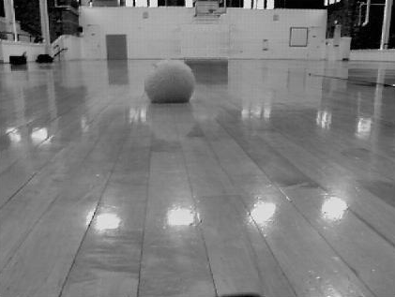
Figure 3: Image with green fuzzy ball
MATLAB has many image processing functions useful to this goal, but there is no one function that can be called to accomplish this task. On the other hand, there is a large and very active MATLAB user community which shares code. Someone had posted a MATLAB function which performs a process called k-means clustering on images. K-means clustering is a statistically based pattern recognition process developed by J.B. MacQueen [14]. A set of data is iteratively processed into k clusters. When the process starts, k random data points are selected as anchors. These points are set as the means of the clusters. Clusters are built by assigning data to the cluster of the closest mean. Once clusters have been assigned a new anchor is selected using the mean of all the data in the cluster. The process then re-clusters all items to their closest mean. The process ends when no data points change the cluster to which they belong.

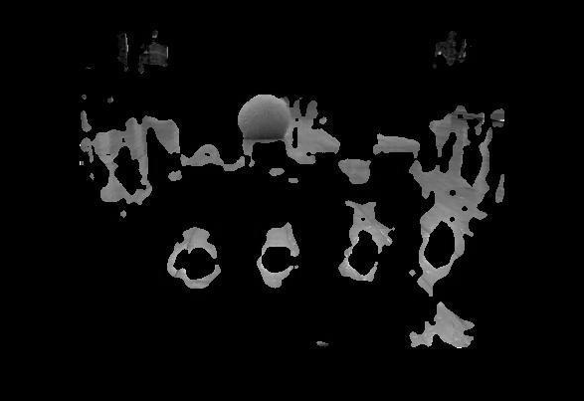
Figure 4: Fuzzy ball image segmented into5 clusters

Figures 3, 4, and 5 illustrate this process. In Figure 3 we see a fuzzy green ball which we would like our robot to be able to identify. Although to our eyes this object stands out sharply against its background, on a pixel by pixel basis, it turns that that there are many pixels in the image which have a fair degree of commonality with those of the ball and these must be filtered out. For example, the tan hue of the gym floor is fairly close in hue to the green of the ball and must be separated out. And, if we are interested in the shape of the ball, we do not want the reflection of the ball on the gym floor to be included in the pixels representing the ball. In addition, there are clear gradations of color and brightness within the ball itself which can get separated and again distort the shape of the ball.

Figure 4 shows what can result if too small a value is chosen for k. In Figure 5 we can see the pixels of the ball clearly emerging when the proper value for k is used.

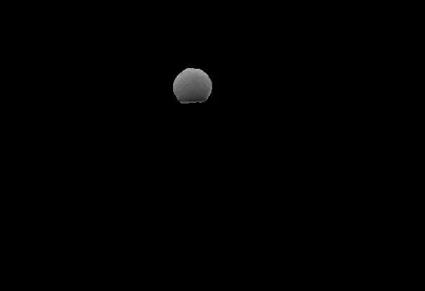
Figure 5: Fuzzy ball image segmented into 6 clusters

5.2. Color Signature and Object recognition

Color segmentation is the first step to object recognition. The next step is to match the object segmented at one point in time to the same object at a later time. Is it the same object or a different one? Shape, of course, is a powerful clue, but there can be objects with the same shape but of different colors.

The task of matching objects by color has many aspects, but the key question is how to obtain a measure which can be used to determine how close the color of an object in one image is to that of an object in another image in order to provide a basis for deciding whether or not both images depict the same object. The problem is made more difficult by the fact that the RGB color representation combines representations of hue and brightness in such a way that it is more difficult to isolate the color component of an image for comparison purposes. There are two color representation systems, yCbCr and L*A*B*, both of which are supported by MATLAB, which are closer in their representation to the way our eyes see color. These were investigated for use in object recognition by color.

The process of determining the extent of match between two regions of pixels was based on the idea of calculating a "color signature" for each and then applying a comparison metric. All three color representation systems mentioned above store each pixel as a triple. Thus, an image is a two dimensional array of triples. MATLAB permits one to separate the image into three separate two dimensional arrays, with each array containing one component of the pixel's triple. The three arrays are called channels. For both the yCbCr and the L*A*B* only two of the channels contain color information while the third channel represents brightness.

It turned out that one of these two representations gave better match results on one of the color channels while the other performed better on the other channel. So it was decided to use both representation schemes, combining the results of each. The formula used is given in Figure 6.

probability = pmcb*pmlb*psdcb*psdlb;
pmcb = min(cbMean1,cbMean2)/max(cbMean1,cbMean2)
pmlb = min(lbMean1,lbMean2)/max(lbMean1,lbMean2)
psdcb = min(cbStd1,cbStd2)/max(cbStd1,cbStd2)
psdlb = min(lbStd1,lbStd2)/max(lbStd1,lbStd2)
where
cbMeanx and cbStdx are the mean and standard
deviation of images 1 and 2 for yCbCr, and
lbMeanx and lbStdx are the mean and standard
deviation of images 1 and 2 for L*A*B*
Figure 6: Color signature formula

Since the four separate probabilities are multiplied together, this creates an artificially low value. Therefore, the threshold used for determining a match is lower than one would normally expect, keeping in mind that non-matching colors yield much lower values. For example a value of 0.7676 indicates a match.

6. What We Learned

This iteration of introducing robotics into our curriculum was the most successful to date. First, it represented the single greatest advance, as we now have a viable hardware/software platform upon which to build. Second, and just as important, a lot was learned regarding what to do and what not to do in the future,

We learned that an arena of operation is the sine qua non of a well-grounded robotics course, second in importance only to the hardware/software platform itself. Although we were able to perform interesting tasks, such as finding and navigating between objects inside a 10' by 10' corral, working in a gymnasium offered the opportunity for a much greater range of tasks. An open space in the range of 30-50' by 30-50' is a desirable venue. Given present budget restrictions and space limitations it is best to secure an arena of operation well before the start of the course. Ideally, a place to store and secure equipment would also be provided.

For us it worked well to have the class work in teams. Designating the teams roles to be filled served to provide focus and give each team member clear objectives to meet. As mentioned, though, the single coder model seemed to create a bottleneck. It would be best to have each team member to have a hand in the coding, even if not all to the same degree. In the future we plan to require each student in class to purchase a student copy of MATLAB, with the Image Acquisition Toolbox added. The current price for this is about the same as the average computer science textbook. There are a number of side benefits to this approach. The student version actually comes with more modules than the regular classroom version. For example, it includes the statistical package which can be very useful for image analysis. Perhaps more importantly, once purchased this software can be used by the student throughout his/her academic career, making this a sound purchase.

7. Conclusions

The most important result coming from our experience is that this hardware/software combination is clearly workable. MATLAB as a programming language is simple enough to be easily learned by 3rd or 4th year computer science majors, yet powerful enough to serve as the robot control system. The API permits full control of the sensors and effectors of the Create. Since it is written in MATLAB, there is no interface problem between high level and low level control of the robot. And the Arduino microprocessor allows the addition of sensors without rewriting the API or control system.

In short, we found that this platform meets our goals, as described in Section 2, and we plan to use it in future offerings of the intelligent robotics course. There is ample opportunity for interesting programming assignments which are accessible to the mainstream computer science student, as well as for challenging assignments for the most advanced student, especially with respect to image processing tasks. In addition, it affords an opportunity for setting off in several new directions for teaching robotics. Mobility and vision are an excellent combination for teaching and exploring issues in AI and cognition.

One of our goals was to develop an intelligent robotics course as a permanent part of our curriculum. After the conclusion of the Fall semester, we developed a syllabus to present to the Computer Science Department. It was voted on and approved in February 2011.

8. Future Directions

When the course is next offered, it is our intention to have a rudimentary human-robot communication system in place. We are currently working on a conceptual parser approach in conjunction with a highly stylized version of English, all within the context of a simple robot world ontology. We were not able to introduce this into the course last fall but expect to do so in the next iteration. Once the basic operating framework is in place, the plan is to bring each aspect of the system to greater maturity with each course offering.

A second major objective for this course in the future is to give students the experience of wrestling with issues in cognitive robotics using issues in understanding human cognition as a point of departure. The symbol grounding problem (mentioned in Section 2) is one such area of inquiry as is also the problem of establishing spatial concepts and spatial reference in the context of human-robot communication (as mentioned in Section 4.4). A centerpiece of this endeavor would be to lift Statton's conceptualization of the sight-touch harmony problem [15] to a more abstract, yet conceptually deeper, level by exploring the harmony of visual input data and spatial experience data from the standpoint of the robot's understanding of its environment.

Now that the basic outlines of an intelligent robotics course are in place, we will also seek ways to simplify the framework in order to make it accessible to high school students, perhaps for venues such as Robotics Clubs. We have had some success bringing robotics into the high school environment and will continue with this aspect of our work.

References

[1] D.S. Touretzky, Preparing computer science students for the robotics revolution, Communications of the ACM (CACM), 53(8), 2010, 27-29.

[2] B. Gates, A robot in every home, Scientific American, 296(1), 2007, 58–65.

[3] R.D. Beer, Dynamical systems and embedded cognition (Cambridge, UK: Cambridge University Press, 2009).

[4] R.A. Brooks, A robust layered control system for a mobile robot, IEEE Journal of Robotics and Automation, 2(1), 1986, 14–23.

[5] M. Mataric, The robotics primer (intelligent robotics and autonomous agents) (Cambridge, MA: MIT Press, 2007).

[6] A. Kronfeld, Amichai. Reference and computation: an essay in applied philosophy of language (studies in natural language processing) (Cambridge, UK: Cambridge University Press, 1990).

[7] S. Harnad, The symbol grounding problem, Physica D 42(1), 1990, 335-346.

[8] M.H. Bickhard, Representational content in humans and machines, Journal of Experimental and Theoretical Artificial Intelligence, 5(4), 1993, 285-333.

[9] J. Bohren, T. Foote, J. Keller, A. Kushleyev, D.L.A. Stewart, P. Vernaza, J. Derenick, J. Spletzer, & B. Satterfield, Little Ben: The Ben Franklin Racing Team's entry in the 2007 DARPA Urban Challenge, The Journal of Field Robotics, 24(9), 2008, 598-614.

[10] C. Gao, I. Hoffman, T. Miller, T. Panzarella, & J. Spletzer, Autonomous docking of a smart wheelchair for the automated transport and retrieval system (ATRS), The Journal of Field Robotics, 24(4-5), 2008, 203-222.

[11] G. Bradski, Gary & A. Kaehler, Learning OpenCV: computer vision with the OpenCV Library (Sebastopol, CA: O'Reilly Media, 2008).

[12] R.C. Gonzalez, R.E. Woods, & S.L. Eddins, Digital image processing using MATLAB, 2nd Ed. (Knoxville, TN: Gatesmark Publishing, 2009).

[13] T. Tenbrink, K. Fischer, & R. Moratz. Spatial strategies in human-robot communication. Künstliche Intelligenz, 16(4), 2002, 19-23.

[14] J.B. MacQueen, Some methods for classification and analysis of multivariate observations, Proceedings of 5th Berkeley Symposium on Mathematical Statistics and Probability, Berkeley, CA, 1967, 281-297

[15] G.M. Stratton, The spatial harmony of touch and sight, Mind, 8(32), 1899, 492-505.

